**How To Make A Peanut Butter And Jelly (PBJ) Sandwich?**

1. Collect all your ingredients.

You will need the following ingredients to make the perfect PBJ:

* Two slices of whole grain or white bread.
* Peanut butter
* Jelly or jam
* A butter knife
* Butter (optional)
* A knife
* A cutting board.

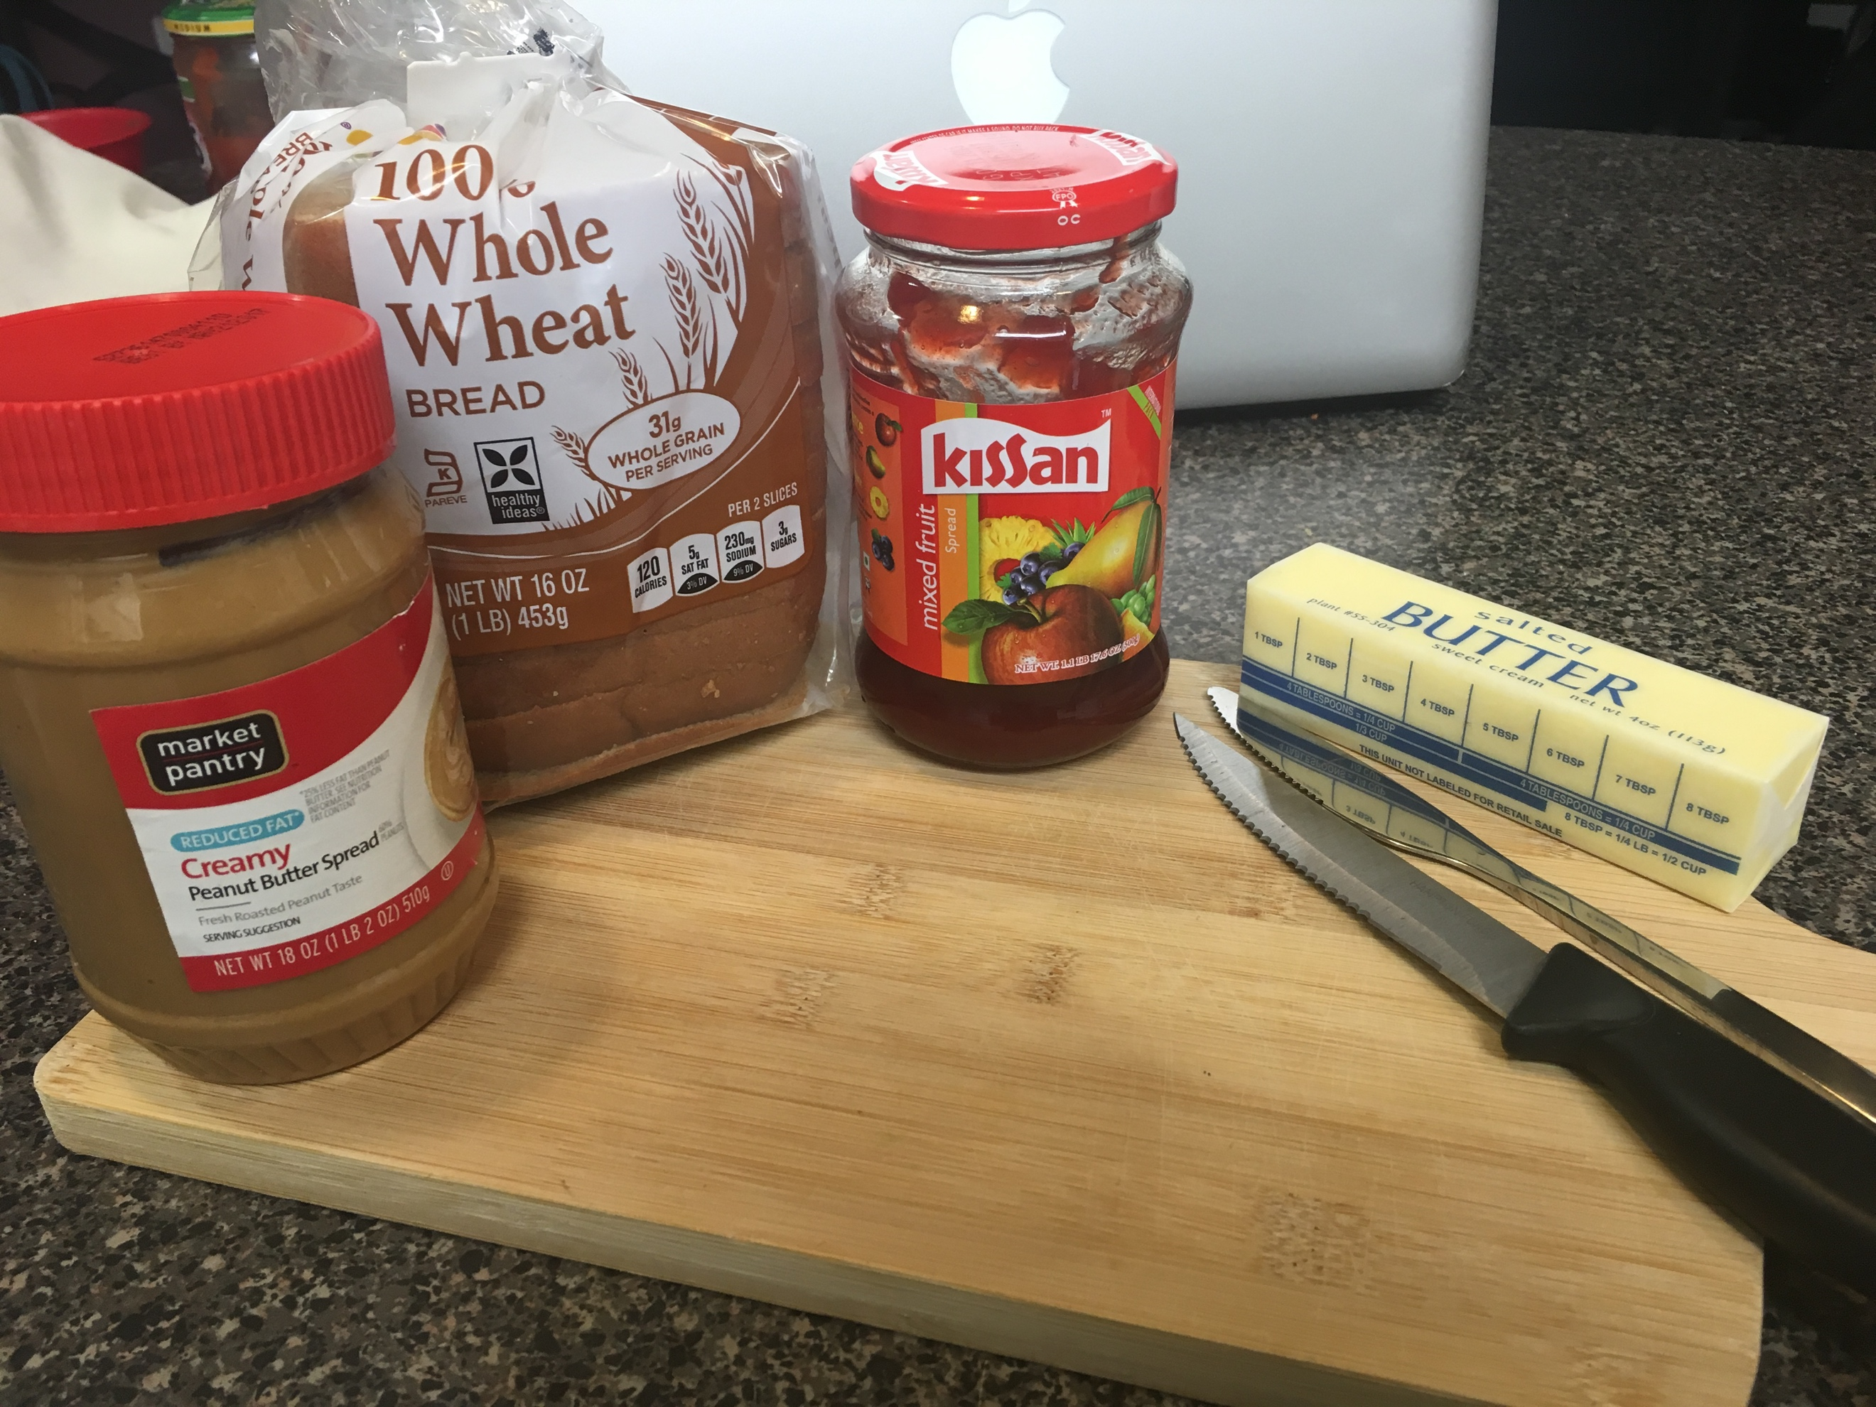

1. Take two slices of your bread.
2. Using a butter knife, spread butter on one side of each slice. This step is optional but completely transforms any ordinary PBJ sandwich.
3. Scoop out some peanut butter and spread it evenly over the buttered slice of one bread.

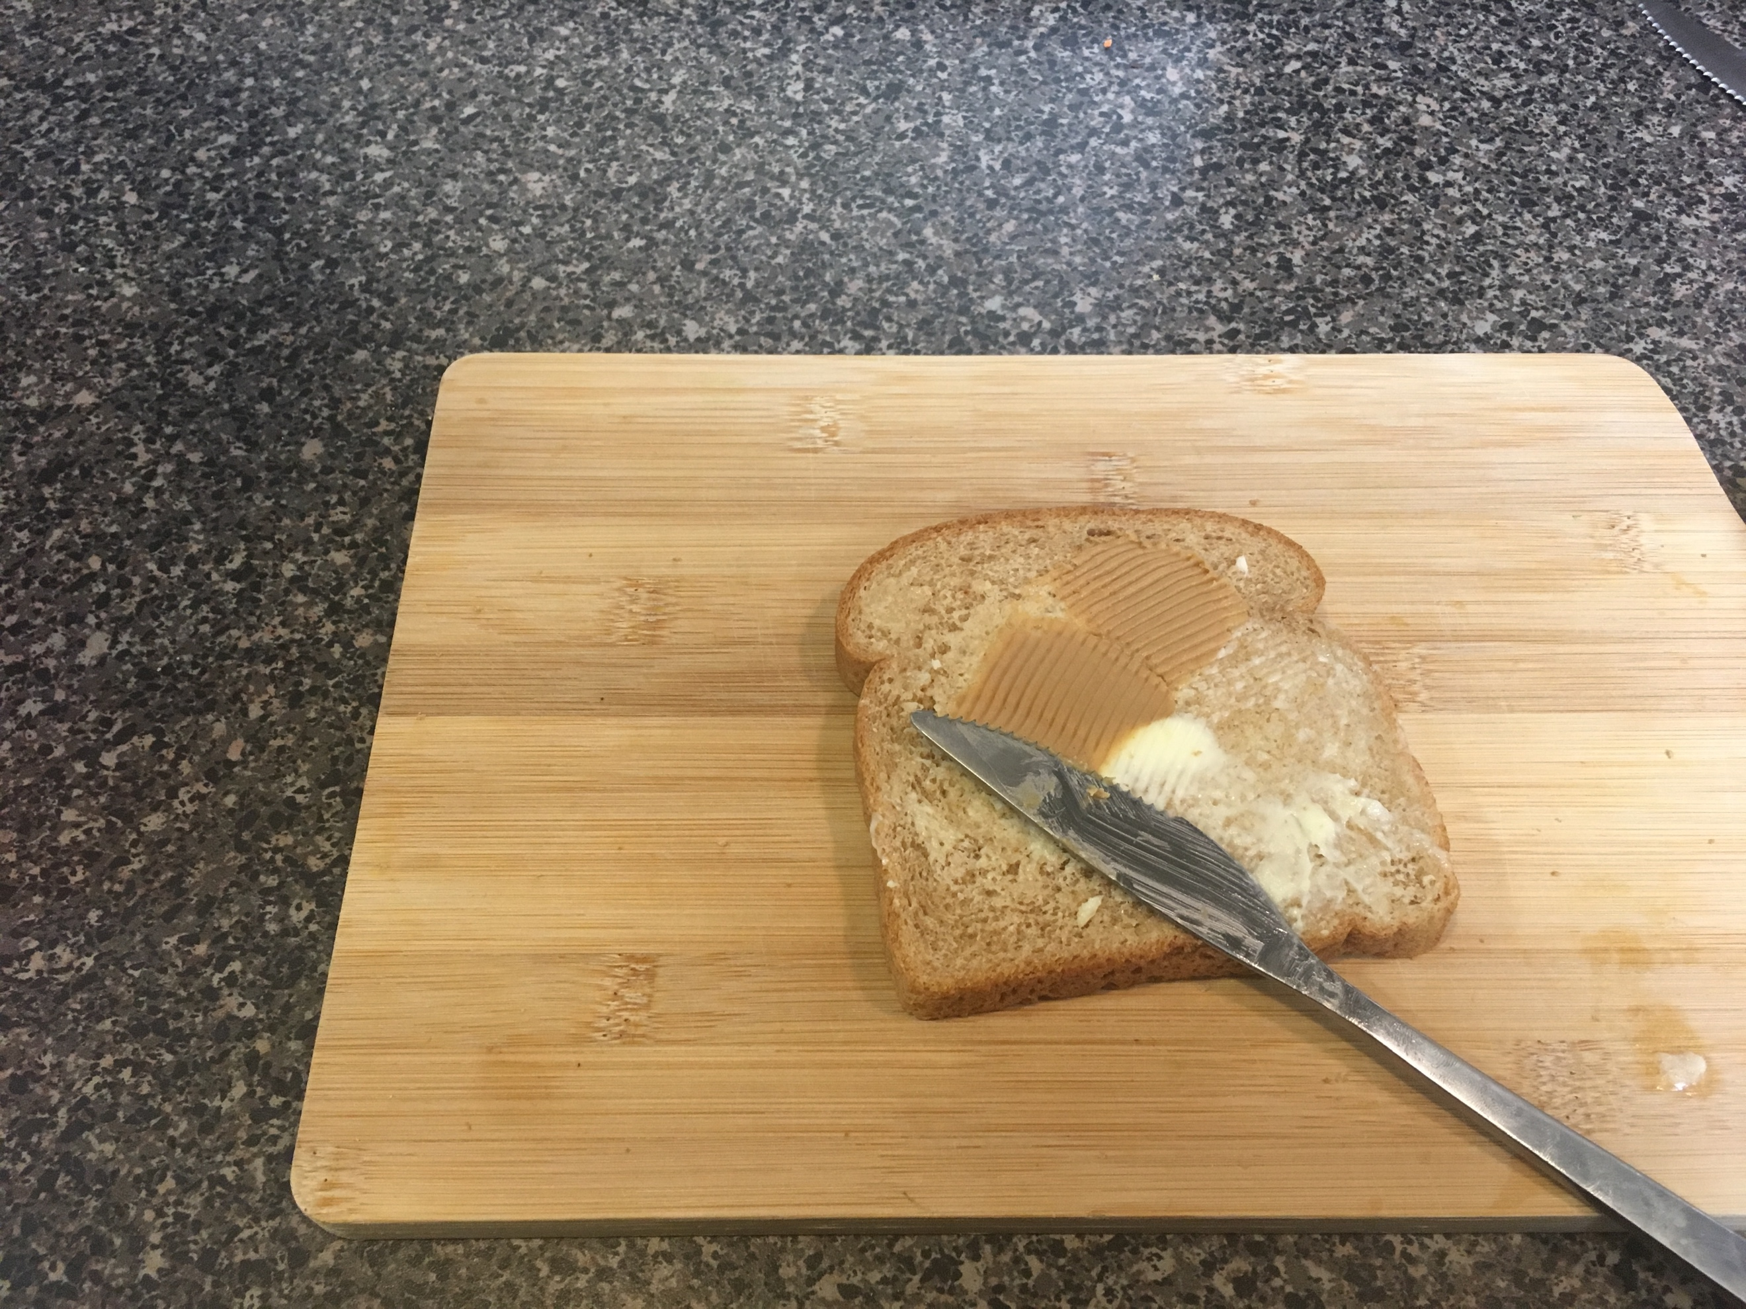

1. Spread some jam or jelly evenly over the other buttered slice.

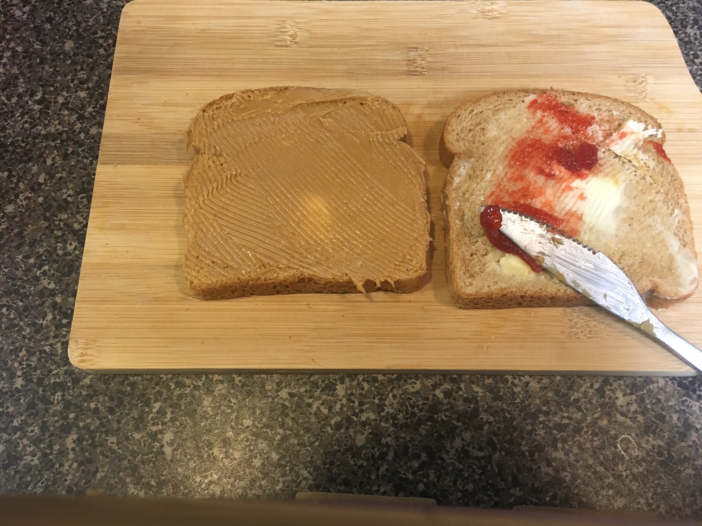

1. Press the two sides of bread together such that the plain sides (i.e. the sides with no spread on them) face outwards.

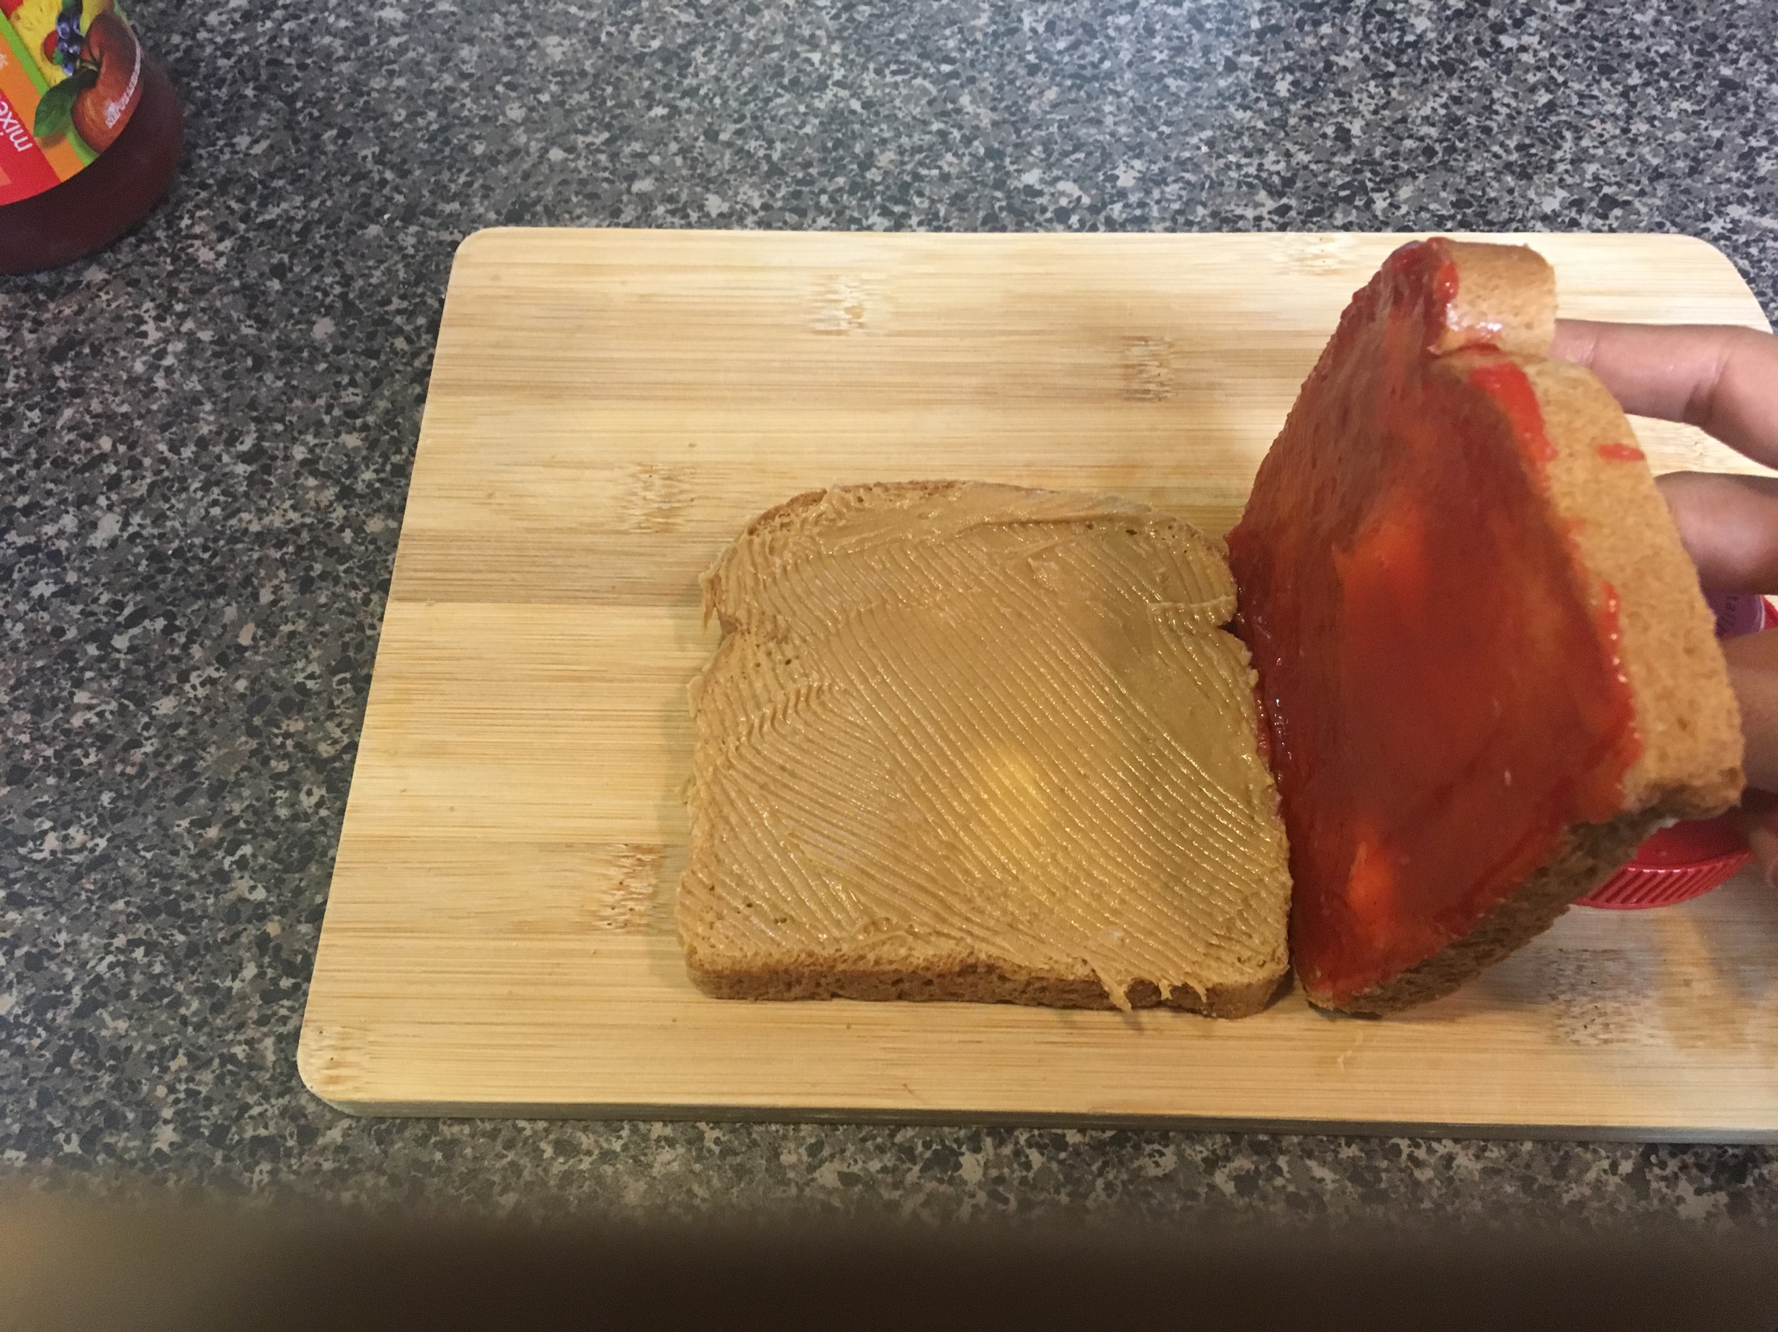

1. Cut the sandwich diagonally to form two triangles. You can also toast your sandwich for extra crunch.

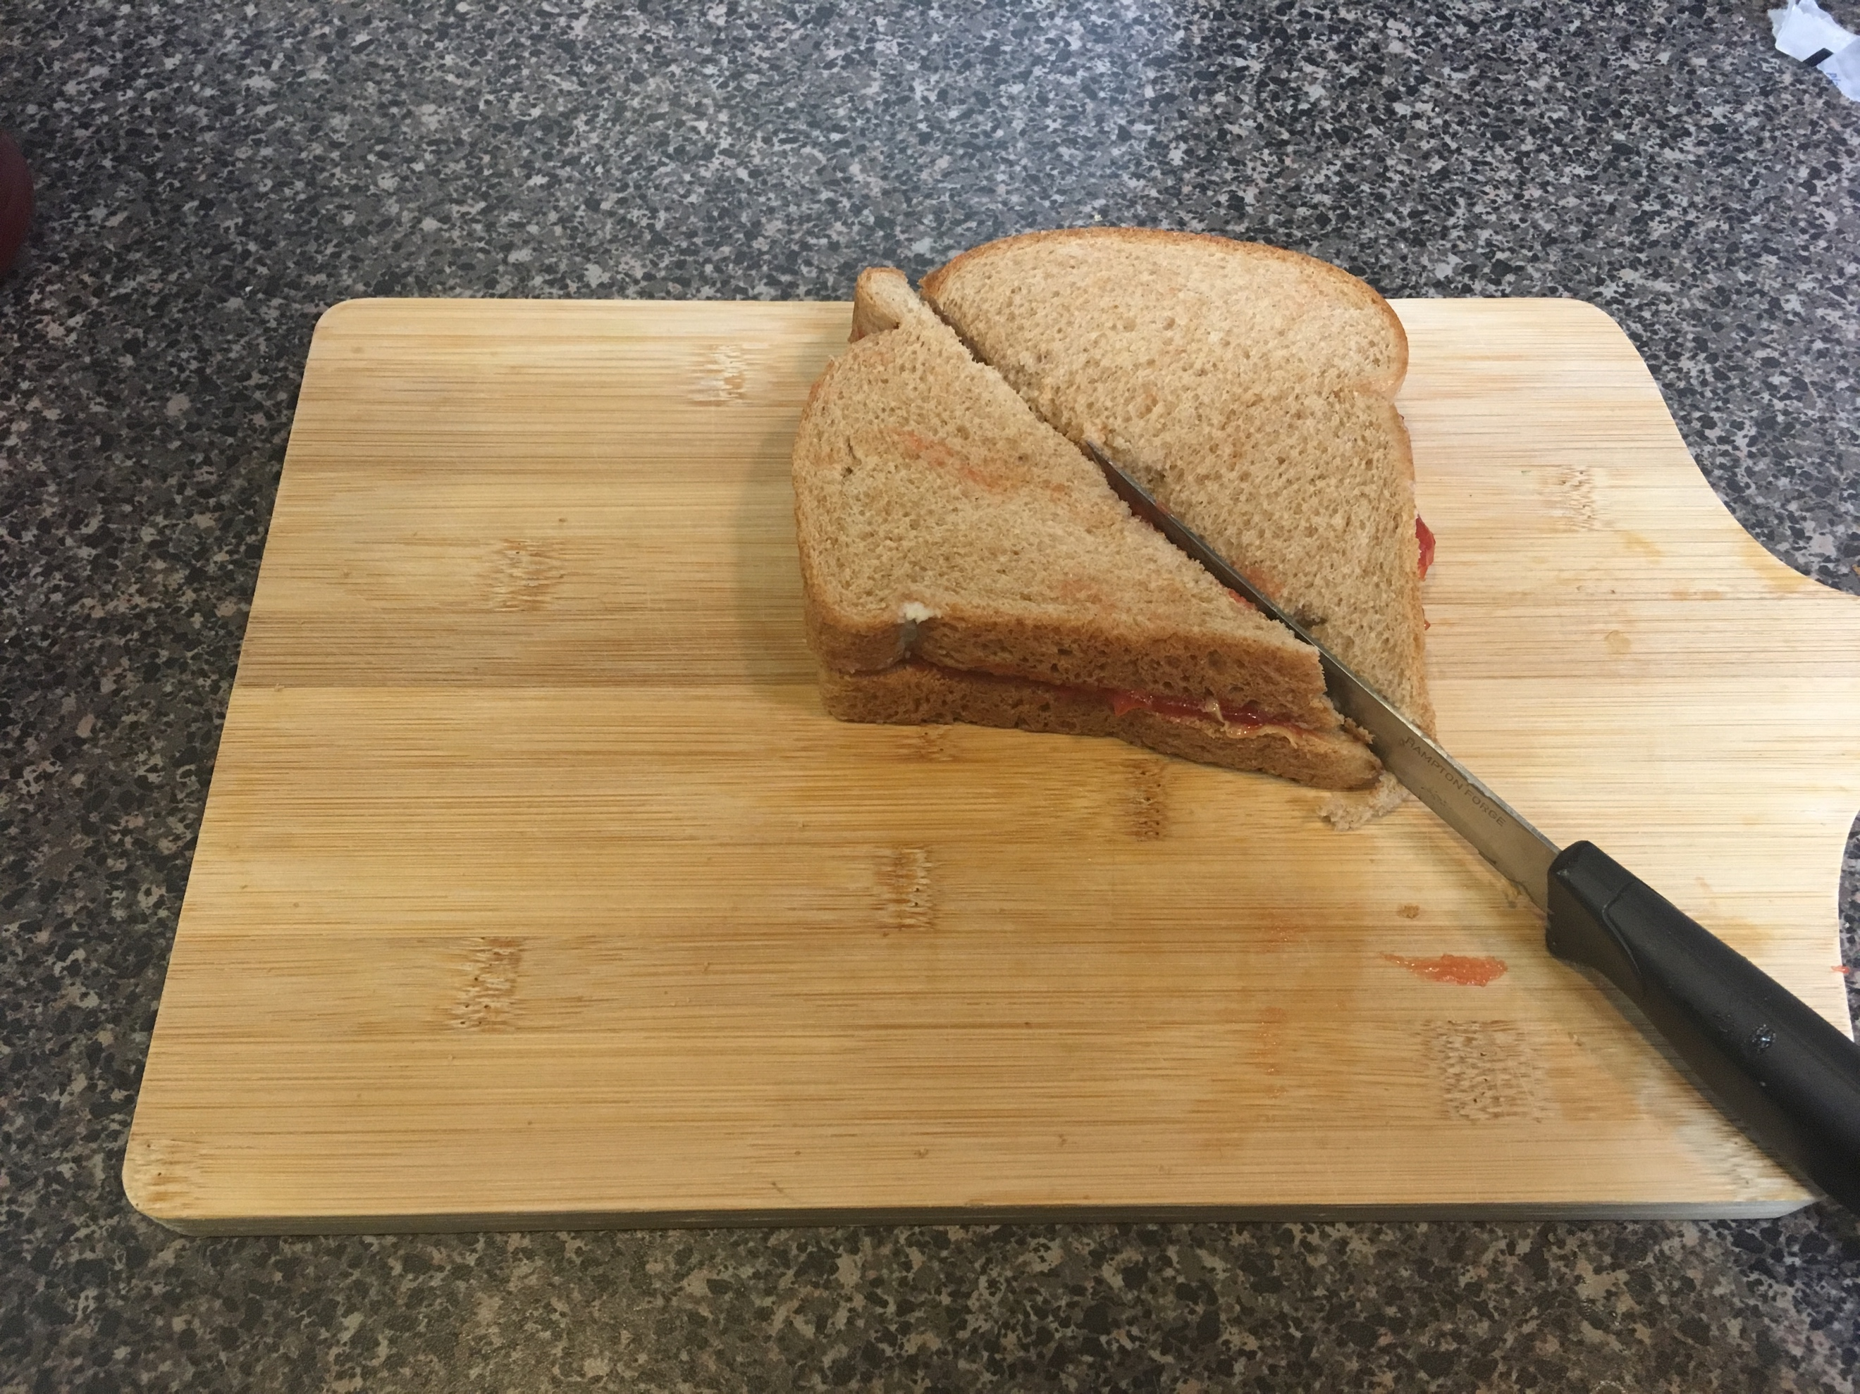

1. Enjoy!!

Word count: 152